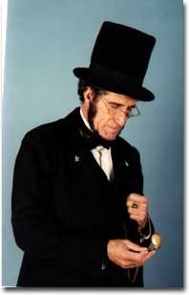
Abe Lincoln
is coming to our school on

_____________________________
& will speak to us at

_____________________________
Homer S. Sewell III, as ABE, will be telling us all about his life..."from the log cabin to the White House."
Be sure to bring your camera for an honest photo opportunity.

